*Using natural history records to determine the effects of city-wide management differences on long-term, landscape-scale pollinator population dynamics.*

Jens Ulrich, started Nov 22, 2022.

**Contents:**

1. **Background / motivation**
   1. **Context**
   2. **Goals**
   3. **Hypotheses and predictions**
2. **Methods**
   1. **Data collection**
      1. *Data Preparation Overview*
      2. *NHC records*
      3. *Spatial data*
   2. **Statistical Analysis**
      1. Higher-level model structure
      2. Lower-level model structure
      3. Software
      4. Prior predictive checks
      5. Simulation
      6. Model diagnostics
      7. Posterior predictive checks
      8. Sensitivity analyses
3. **Preliminary Results** haven’t included anything here yet in this doc
4. **Ideas for expansion/different approaches**
5. **Background / motivation**

**1a) Context**

By evaluating studies that compare pollinators and their interactions with plants in urban versus rural landscapes or along urbanization gradients, multiple reviews synthesize our understanding of how urbanization shapes pollinator populations and communities (Wenzel et al., 2020; Fenoglio et al., 2021) and the interactions they make with plants (Harrison and Winfree, 2015; Theodorou, 2022), showing that pollinator populations, communities and the interactions that they make with plants are clearly different in cities and towns (relative to?).

But if we want to implement conservation actions that maximize the value of urban areas, we need to know how alternative urban management decisions impact pollinator populations and communities that exist in the urban environment. This is especially important given that urban areas will continue to grow in coming decades, replacing natural habitat at broad landscape scales (Guneralp & Seto, 2013; U.N., 2018).

Many small-scale studies look within a city to examine how local pollinator abundance and diversity are affected by differences in the local environmental conditions such as temperature (Adams et al., 2020) or flower resources (Adams et al., 2020; Gerner and Sargent 2021), and by the landscape context including the amount of impervious surface cover and tree cover within the foraging area of local pollinator collection (Adams et al., 2020; Gerner and Sargent 2021, Hyjazie and Sargent 2022). From these studies we know that local pollinator abundance and diversity is especially tied to the local flower abundance and species richness and local proportion of native flowering plants (Adams et al., 2020; Gerner and Sargent 2021). Differences in the local pollinator abundance and diversity can also be explained by the local habitat type, which captures variation in multiple local and landscape variables (Normandin et al. 2017, Baldock et al. 2019). Meta-analysis also tells us that, across studies that collect pollinators from semi-natural areas embedded in an urban matrix, ‘patch size’ of the semi-natural area where pollinators are collected (defined as?) has the largest effect on the local abundance and diversity of those pollinators (relative to other common explanatory variables such as… ?) (Beninde et al. 2015) .

Although within city-comparisons provide valuable information on how land use (?) at a local scale predicts the value of urban habitat for pollinators (e.g., Beninde?), we have little information on how management decisions and land use change patterns that emerge at larger temporal and spatial scales impact pollinator population dynamics over the long-term. Examining how pollinator populations respond to management at larger temporal and spatial scales is an important knowledge gap; we currently lack the ability to predict whether management decisions increase local abundance and diversity through enhanced reproduction and survival versus simply through habitat selection mediated movement (REF? Maybe a review like Baldock 2020?) ().

Further, local pollinator abundance and diversity is linked to abundance and diversity to abundance and diversity in the surrounding landscape, where local extinction and colonization is mediated by dispersal of individuals from habitats at larger spatial scales (Ponisio et al., ecology letters). If population dynamics are driven by an interplay between local reproduction and survival with dispersal across the landscape, then examining how city-wide features impact entire pollinator metapopulations is critical for understanding how to maximize pollinator population stability in the long run.

We also lack a good understanding of the role of dispersal among local subpopulations in maintaining pollinator diversity at a larger scale. If, as predicted from metapopulation theory (ref for this??), urban pollinator populations function as a connected metapopulation, where local extinction and colonization is mediated by individuals from the larger landscape area, then practices that promote land patches that operate as population sinks, connected by corridors that promote dispersal, are important considerations in urban land use planning. Furthermore, if population dynamics are driven by the interplay between local reproduction and survival with dispersal across the landscape, then examining how pollinator metapopulations responds to city-wide features is critical for understanding how to maximize pollinator population stability in the long run.

Critically, we currently lack studies that make among-city comparisons, likely because of the logistical difficulties associated with collecting standardized data in replicated format required to perform large-scale cross landscape comparisons. Fortunately, the proliferation of citizen science data and digitized museum records, present an opportunity to make inferences across large spatial and temporal scales. Occupancy modeling approaches that account for spatial and temporal variation in detection ability provide a framework for inferring population trends (Mackenzie). Occupancy of a species provides a proxy for population dynamics (Mackenzie), and whether implicitly (or explicity stated) at a broader spatial scale might provide a proxy for metapopulation dynamics (whether the metapopulation as a whole is stable or declining, and what environmental factors contribute to this). Paired with modeling choices that account for the unstructured and opportunistic nature of these data, this approach has emerging potential for uncovering broad global change impacts (Altwegg et al., 2019; Kharouba et al., 2019; Guzman et al., 2021; Jackson et al., 2022; Shirey et al., 2022; Davis et al, 2022)

**1b) Goals**

Goal: To identify how land use in cities impacts long-term dynamics of pollinator populations across urban landscapes. Using a set of data extracted from (briefly describe), I will examine the effect of differences in land use among urban areas on pollinator (occupancy? Diversity?) using an occupancy modeling approach (list a source REF). I focus on data available for pollinators and land use within urban areas in the state of California, which allows me to reduce unaccounted landscape heterogeneity, and control for differences in environmental/land use data. I also focus on comparisons among urban landscapes within a contemporary era (i.e., at least after year 2000), given availability of NHC data and quality environmental data, and also to avoid the assumption that urban landscapes were comparable in a pre-modern era. The taxonomic scope of this project will include two important pollinator taxonomic groups: hover flies (Diptera – family Syrphidae) and bumble bees (*Bombus*).

**1c) Hypotheses and predictions**

H1: Because greenspace is associated with nesting habitat (non-impervious surface for ground nesting as well as vegetative materials for aboveground nesting) and potentially with increased food supply (vegetation typically includes plants that offer pollen and nectar rewards), increased greenspace in the urban landscape positively impacts the stability of pollinator metapopulations.

Prediction: After accounting for a variety of urban characteristics (population density, area of the landscape site, and spatial autocorrelation between landscape sites) as well as heterogeneity in the detection probability of pollinators across space, time and taxa, the equilibrium **occupancy rates of pollinator species among urban landscapes will be positively associated with average NDVI** (a metric of proportion (?) green vegetation cover) in the landscape. [Note that this can be said very simply – urban areas that devote more space to plant cover – a predictor of available green space - are predicted to have higher pollinator biodiversity – it might be worth looking over the entire intro to be sure that is easily plucked out by the reader. Also, your intro suggests connectivity might also be important – can you add that to your analysis?]

1. **Methods**

**2a) Data Collection:**

* + 1. *Data Preparation Overview*:

Data collection proceeds according the diagram below. Modeling decisions must be made with considerations including the spatial grain of the sites and the temporal grain of the occupancy interval, which will potentially influence the model output results. The workflow has been set up in such a way that raw data downloaded from GBIF can be easily reprocessed, by simply changing the input values in the prep_data() function before feeding to the model for parameter estimation.

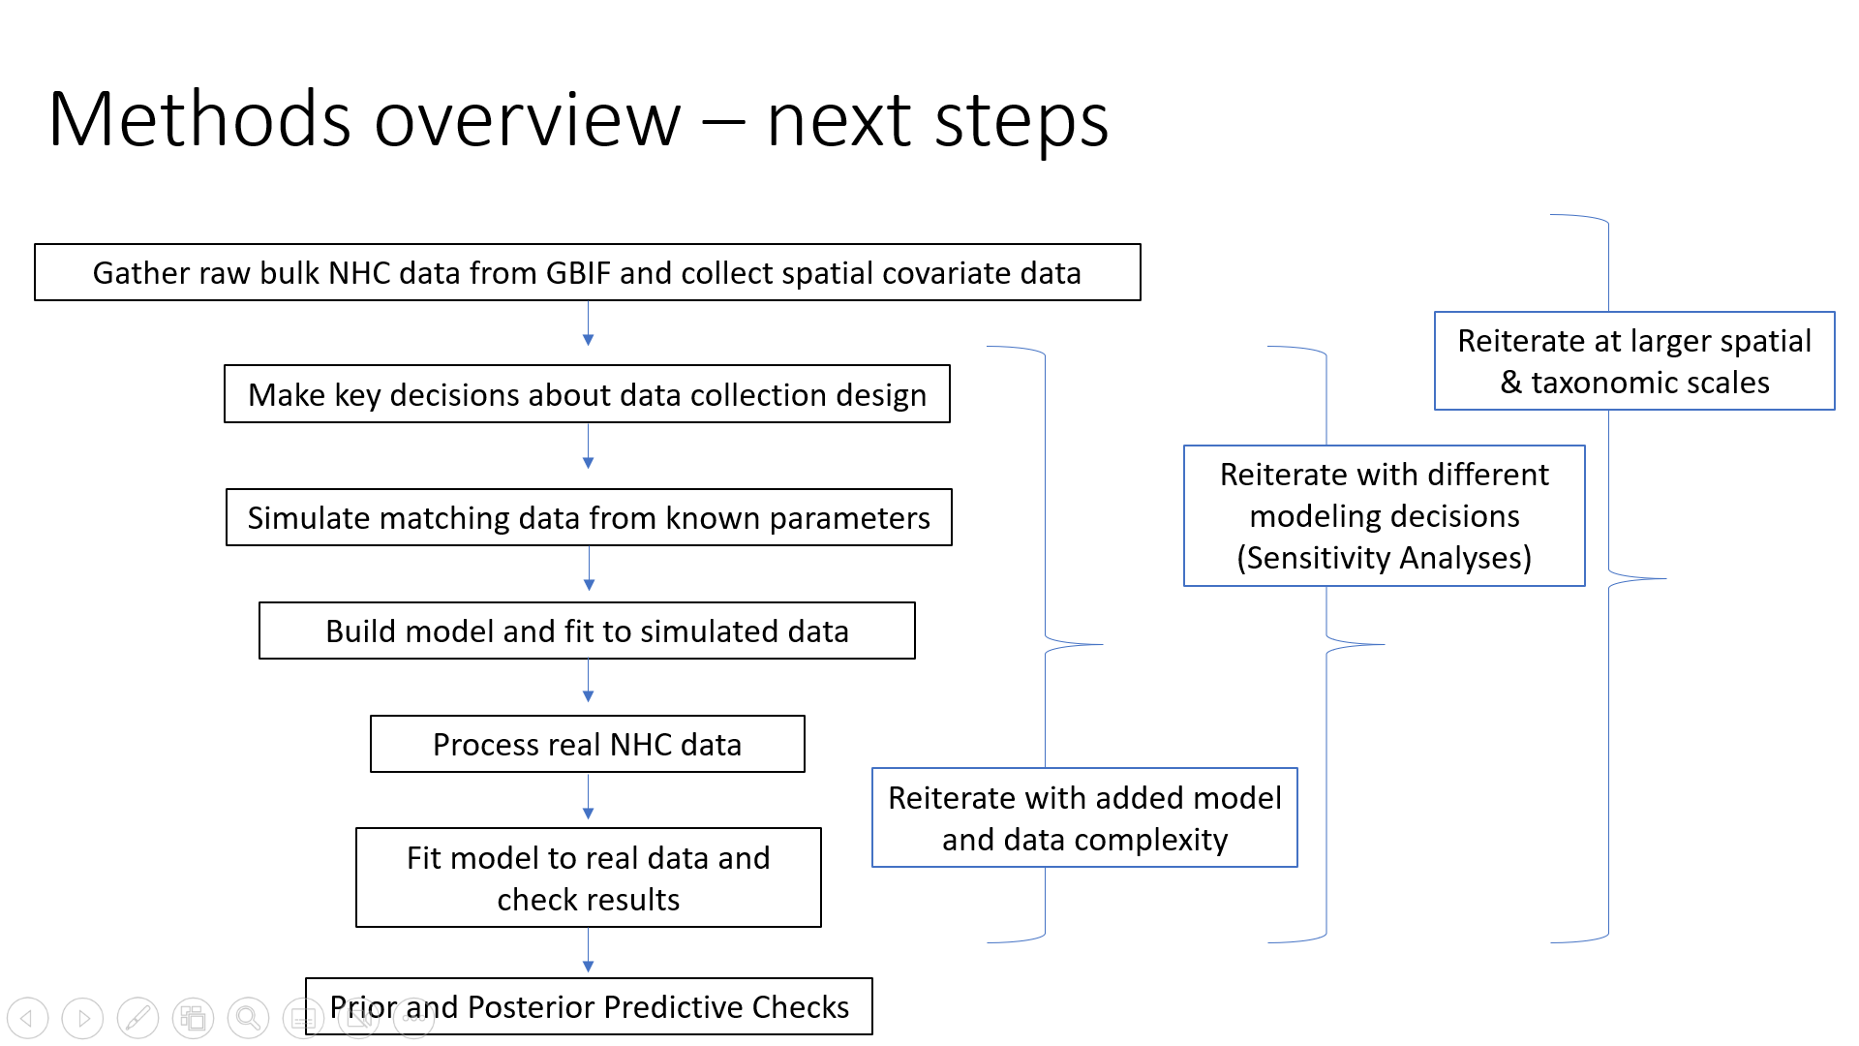

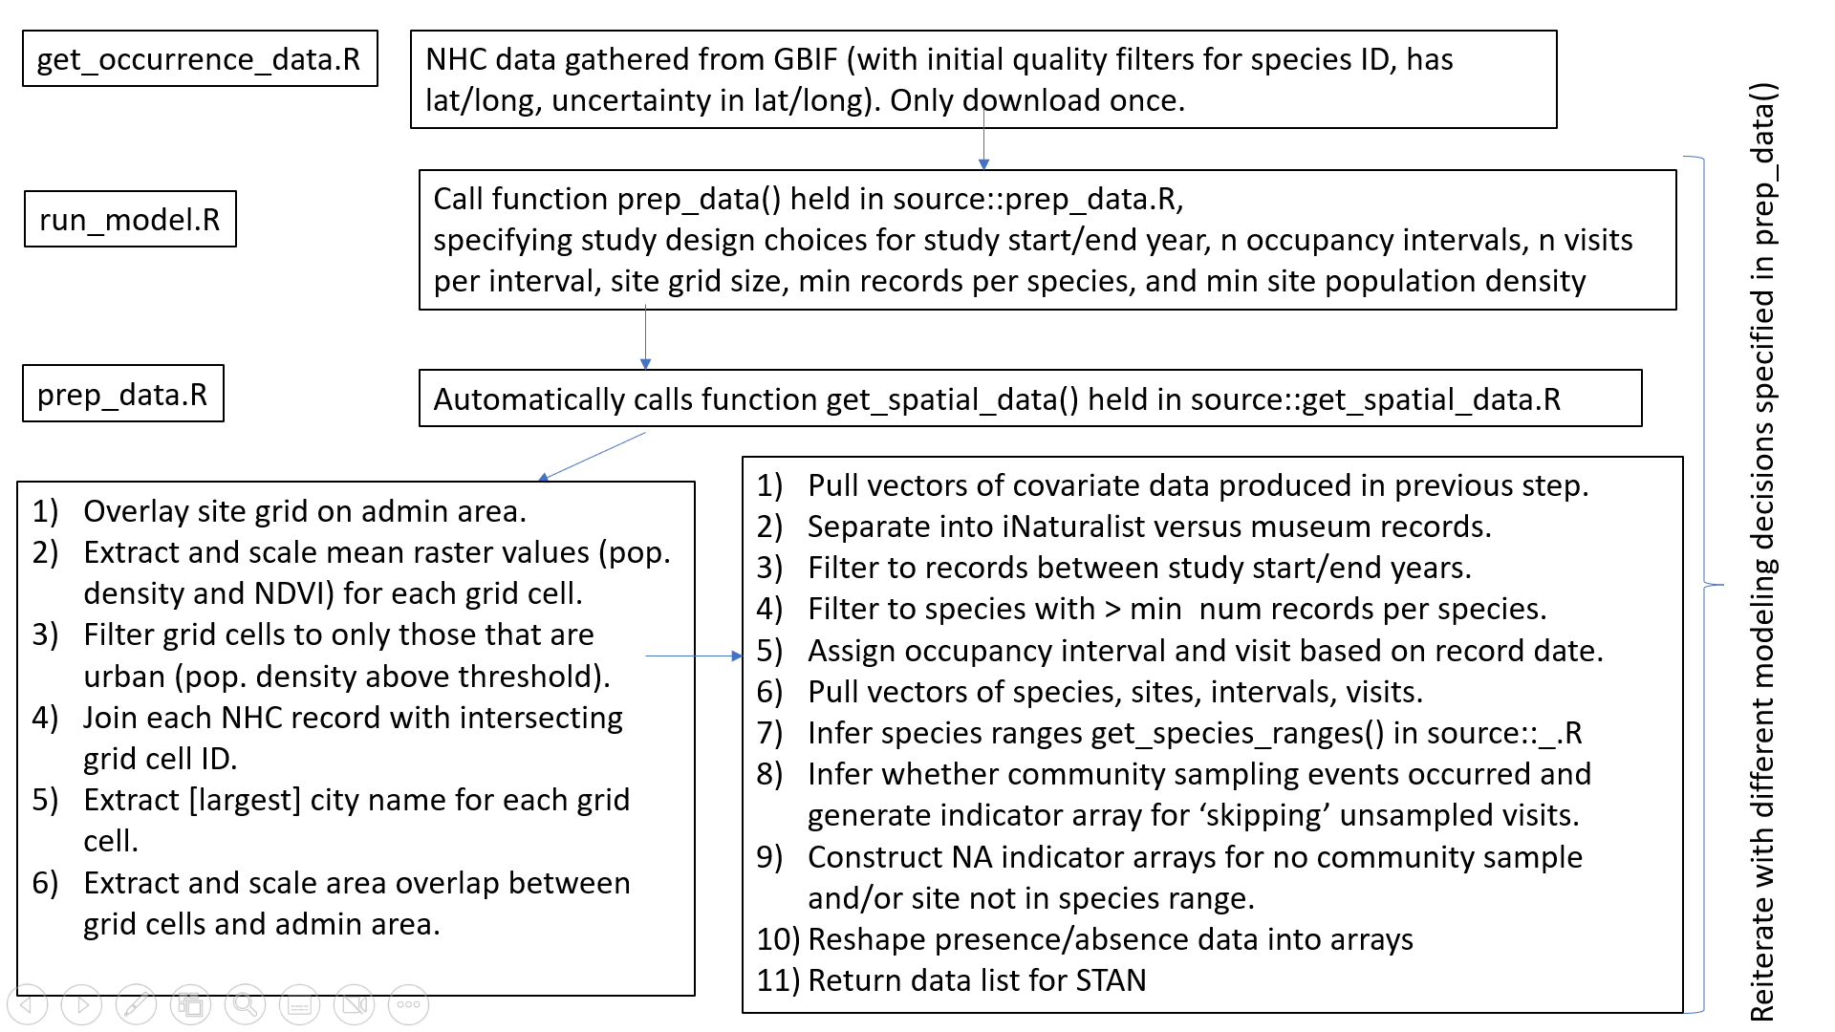 ***Figure XA and XB: Data collection and preparation simplified workflow overview and detailed overview for the data processing step.*** *Importantly, the model outputs should be revaluated across different modelling decisions that can be customized in the head of the top level function ‘prep_data()’. The process is repeated separately for the two taxonomic groups, hover flies and bumble bees. Currently this process is missing estimation of species range area (because I haven’t gotten that far yet).*

* + 1. *NHC records*:

Natural history collection records were requested from GBIF using the R package ‘rgbif’. (add Syrphidae download code here, add *Bombus* download code here).

For Syprhidae I requested data for all available preserved specimens and human observations identified to the species level and which contained latitude and longitude coordinates, including specimens from any year. I ensured that the uncertainty in the coordinates was less than the spatial extent of the site area, by….. These initial filters result in a dataset comprising 34,217 unique observation records. All human observations are research-quality observations contributed from iNaturalist (20153 records). Preserved specimens (14,064 records) originate from multiple sources, most prominently including the Natural History Museum of Los Angeles County (LACM) (10,413 records) and the Randall Morgan Insect Collection at the University of California, Santa Cruz (UCSC) (2,347 records). 85.3% of these 34,217 records originate from the year 2000 or later, representing 137 species, including the most common *Toxomerus marginatus* (>3,500 records since year 2000 or later, Figure X).

For bumblebees… (was thinking with potentially sticking with bumble bee watch data rather than inat, purely because there’s so much iNat data and it might take a lot of effort to sort through the muck). Otherwise repeat the process with bumblebees.

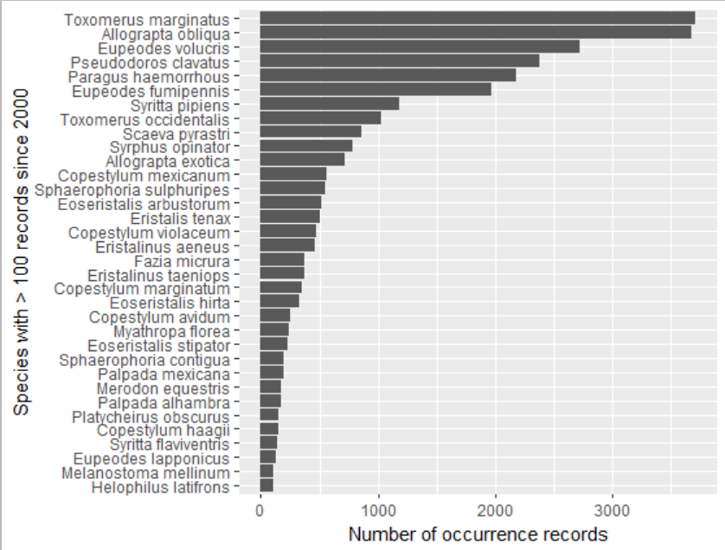

***Figure X: Number of records for hover fly species with 100 or more records collected in California since the year 2000.***

iNaturalist records for hover flies generally appear to increase through time (Figure X). iNaturalist launched in 2008 and so theoretically all occurrences should arise from 2008 or later but there are a handful (<10) records that occur before 2008, presumably ID’d after the fact from saved photographs?. In contrast, there is no clear/consistent pattern in hover fly museum records (Figure X). Notably there is big drop in the most recent years. I suspect this is because there is some lag between a researcher collecting a specimen, IDing, housing it in a local collection while working towards data publication, depositing the specimen as a voucher, and then that voucher being digitized. This may shape how we model detection rates for preserved specimens (or prohibit us from using preserved specimens for the most recent era).

What will we see for bumble bees?

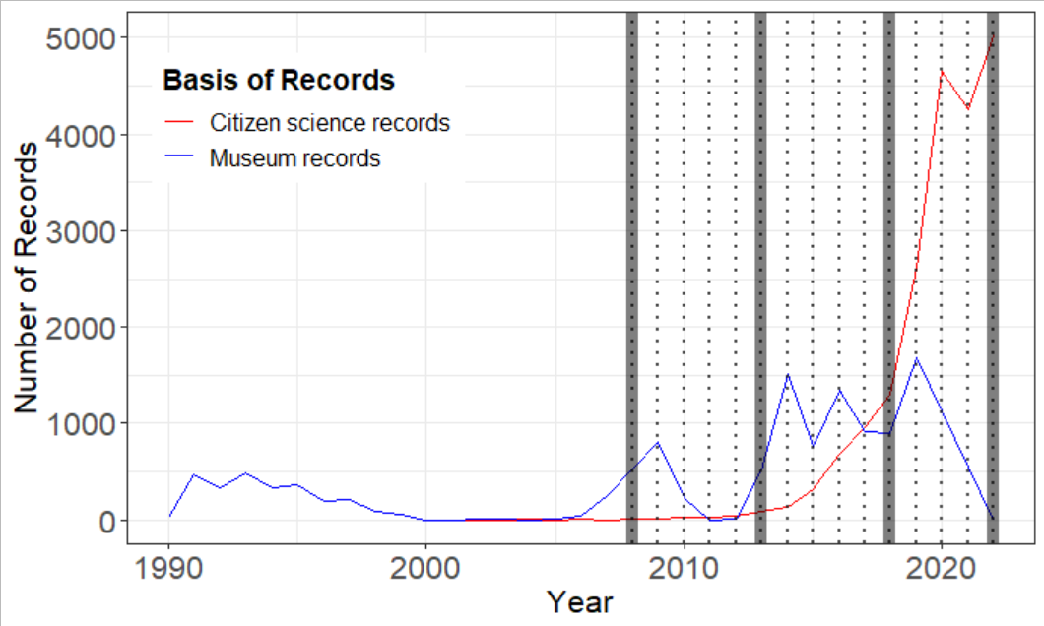

**Figure X: Number of hover fly NHC records contributed by iNaturalist (red) and by preserved specimens in museums (blue) through time.**

* + 1. *Spatial data:*

The administrative areas (state shapefile) was downloaded using the ‘tigris’ package in R.

To account for effects of population density on both the ecological and observation processes, I downloaded a population density raster from (<https://sedac.ciesin.columbia.edu/data/set/gpw-v4-population-density-rev11/data-download>). The population density raster was constructed from data taken in year 2015 and is calculated at a 1km² resolution. The mean population density per site is calculated based on the spatial grain chosen at the head of the modeling workflow. The grid cell sites are then filtered to only those that are above a threshold of minimum population density (default = 100 people/km²) (Figure X). This importantly allows us to compare pollinator population trends between urban areas, since non-urban areas may differ in many ways – for example, an area with low population density could be a monoculture crop landscape with heavy pesticide use, or it could be a pristine remnant habitat landscape in a protected park. Limiting the comparisons to those made between cities helps us to focus the outputs on the effects of differences in city management on pollinators. The population density in each grid site that remains is then z-score scaled around the mean population density of sites included in the dataset (Figure X).

Normalized difference vegetation Index (NDVI) data were downloaded from (California Department of Fish and Wildlife, <https://gis.data.ca.gov/datasets/CDFW::naip-2020-ndvi-california/about>). brown (defined as less healthy vegetation or no vegetation) to red to green (defined as healthier vegetation or more “greenness”). The mean NDVI per grid site is calculated based on the spatial grain chosen at the head of the modeling workflow. The NDVI in each grid site that remains is then z-score scaled around the mean NDVI of sites included in the dataset (Figure X, haven’t done this yet).

Initially I will download data from a single year, however, data is available for 2012, 2014, 2016, 2018, and 2020. It might be a good idea to match the NDVI data to the site for year most closely corresponding to the each occupancy interval. The data are at 1m resolution for 2012 and 2014 and 60cm resolution for all following years. Visually there is some variation between years. It would also be good to verify that the data from different years was collected at the same time of the year (data from April is probably much more “green” than data if it were collected in August in a different year. For this reason it may be easier to just stick with data from a middle time point. Also note that NDVI may not be a great metric if natural habitat is characteristically dryland/desert – i.e., I think NDVI will be low in southeast California and high in northwest California, but this not necessarily meaning that there’s less natural habitat. Further, NDVI can capture urban crop land which may be having a different effect versus urban natural habitat areas. Some things to think about anyway…

Could try to get broader spatial scale NDVI from ESRI using lab account: <https://www.arcgis.com/home/item.html?id=aa9c87d6f17b452296252bd75005f6a4>

City areas polygons were downloaded from (<https://maps.princeton.edu/catalog/stanford-zd071bk4213>). I extracted the city name of the largest city by population that overlaps with each grid site. This provides potential future opportunity to link an additional covariate of interest that varies with city identity.

I calculated the intersection area between each grid site and the land cover of the administrative area (Figure X). I included site area given that some grid cells are smaller than others because they are along the coastline or along the border of the administrative areas from which NHC records were obtained (i.e., we did collect data from Mexico, but some sites straddle the border between California and Mexico). Generally we expect more species to be found in larger site areas and so we want to account for this in our model. The site area is scaled before being fed to the model.

Following construction of the sites and extraction of the ecological and observation covariates for the sites, I filtered the NHC data to only those records that originate from the urban sites (this was a pretty large portion but how much? Does change slightly depending on the modeling decisions entered in prep_data()). Using their latitude and longitude values, each NHC record was then matched with the corresponding spatial grid site. I also then filtered out all NHC records with uncertainty in the coordinate accuracy above a maximum threshold of _ (most coordinates have a certainy of less than 1km, mean and sd = ).

Separate occurrence arrays for iNaturalist data and museum record data are then produced (where presence/absence of species at sites in an interval at a visit is denoted). These separate detection data arrays are handled differently by the model using an integrated hierarchical approach (Zipkin et al., 2021; Davis et al., 2022)

Community sampling y/n -> made an indicator array, if no community sampling event happens then the event is excluded from contributing to the detection estimation process and from the ecological process. Basis of determining whether a community sampling event occurred..

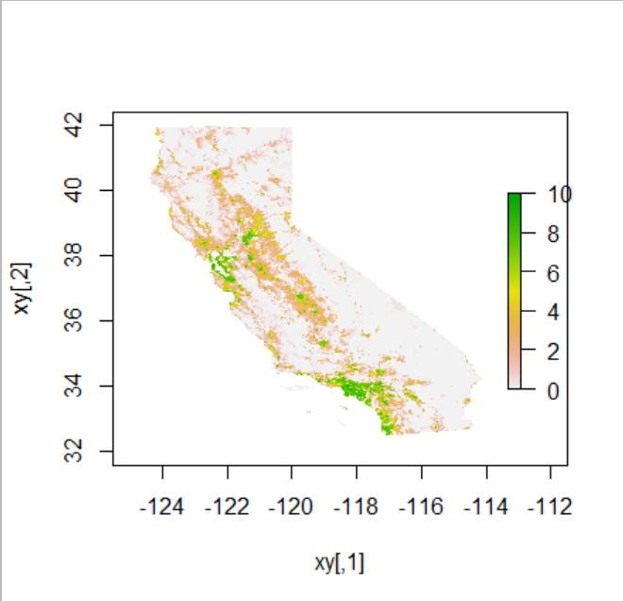

**Figure X: Population density raster.** Log(Population density + 1) is displayed from low population densities (white to red) to high population densities (green).

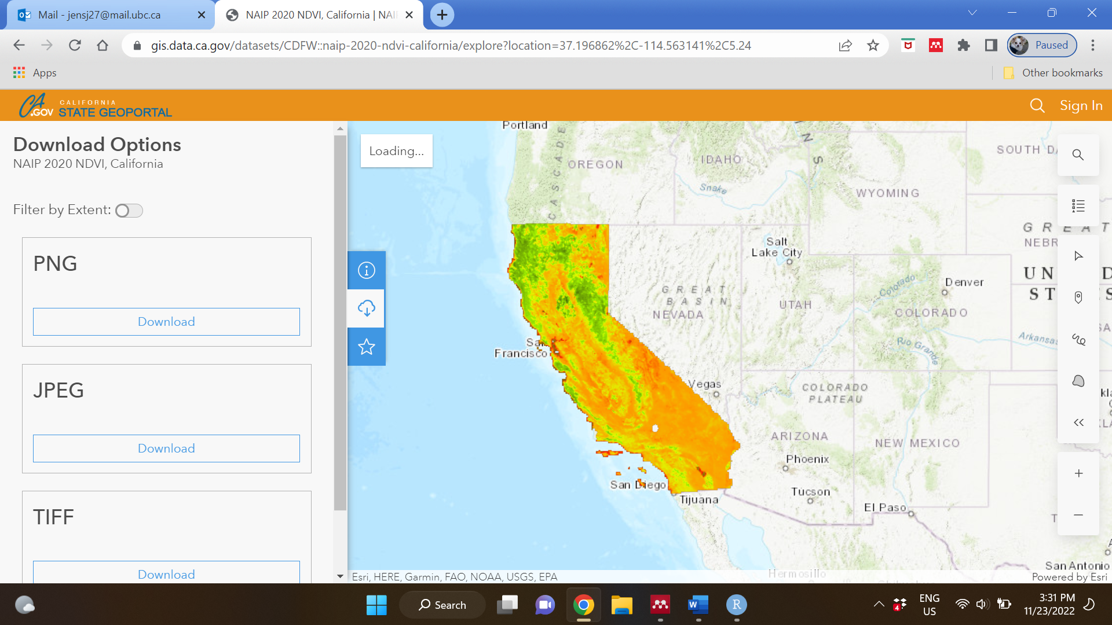

**Figure X: NDVI raster.** NDVI is displayed from brown (low vegetation greenness) to red to green (high vegetation greenness).

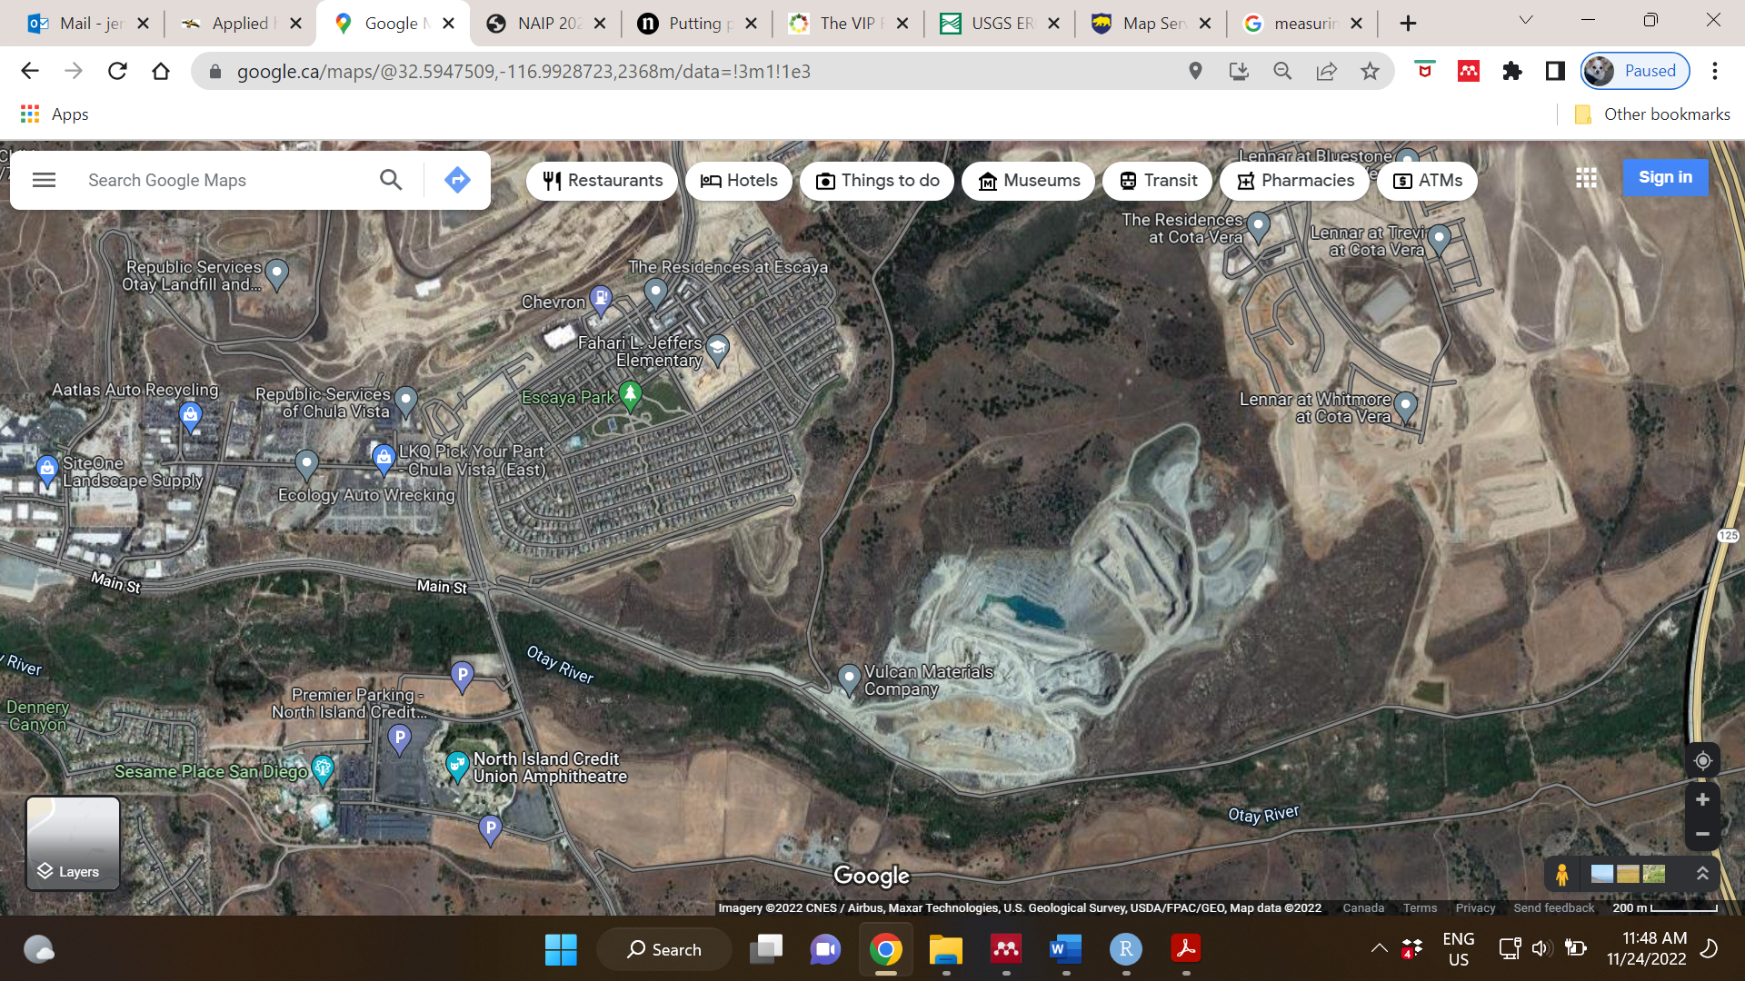

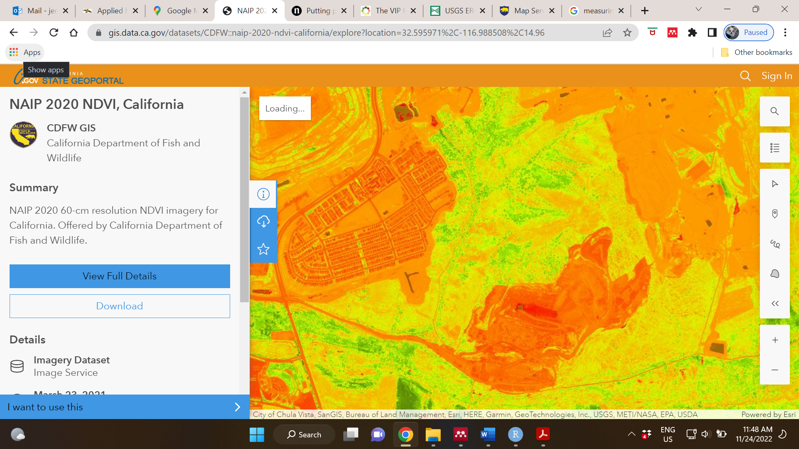

**Figure X:** Comparison between an aerial view and the vegetation index.

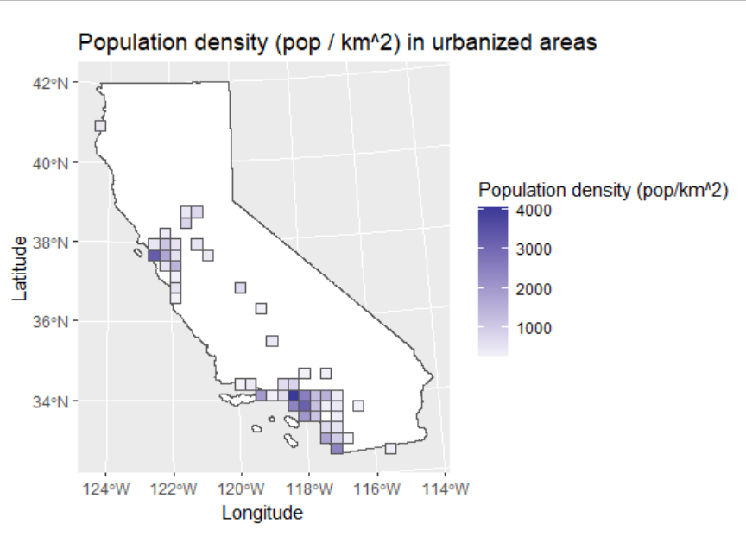

**Figure X: Human population density.** Darker shades indicate grid cells with higher population density. These covariate data are scaled before being read by the model.

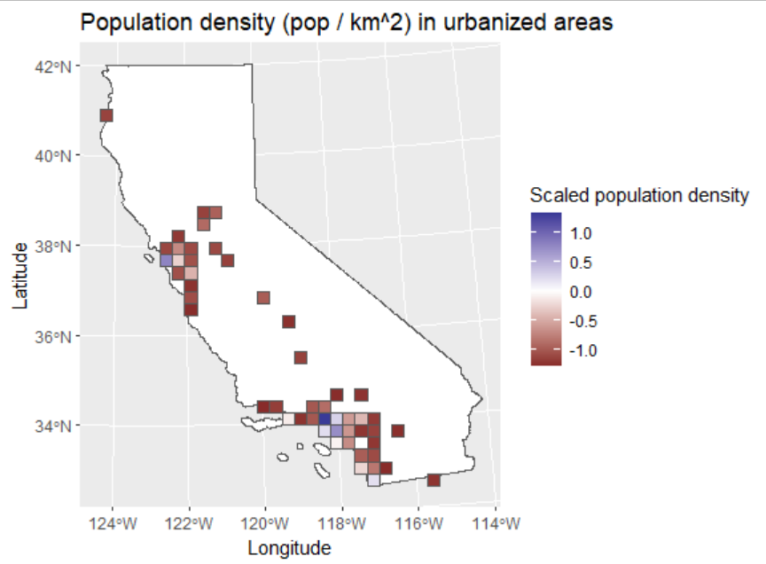

**Figure X: Scaled human population density.** Data were scaled using a z-score scaling method. A value near 0 (white shading) indicates a grid cell that is near the mean population density. Values that are dark blue have higher population densities versus the average grid cell and values that are dark red have lower population densities versus the average grid cell. These are the data that model uses to estimate the effect of population density on the ecological and observation processes.

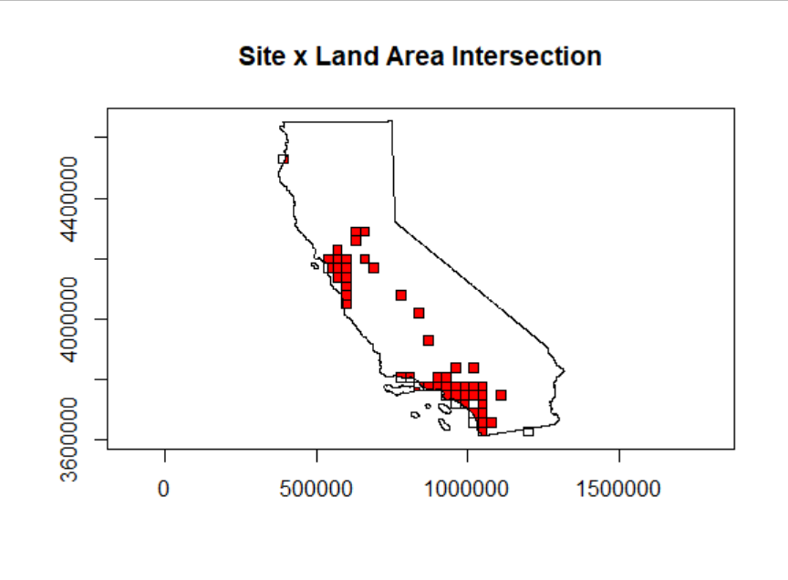

**Figure X: Site area.** Red indicates area in each grid cell that overlaps with land cover within the administrative area from which NHC records were gathered. Grid cells that are along the coastline or straddling an administrative border have less red area versus grid cells that are fully embedded in land area. The proportion of each grid cell that is overlapping with land cover within the administrative area (red) is calculated, the data are then scaled around the mean using a z-score scaling method. These data are then used to estimate the account for an effect of spatial area on the ecological process.

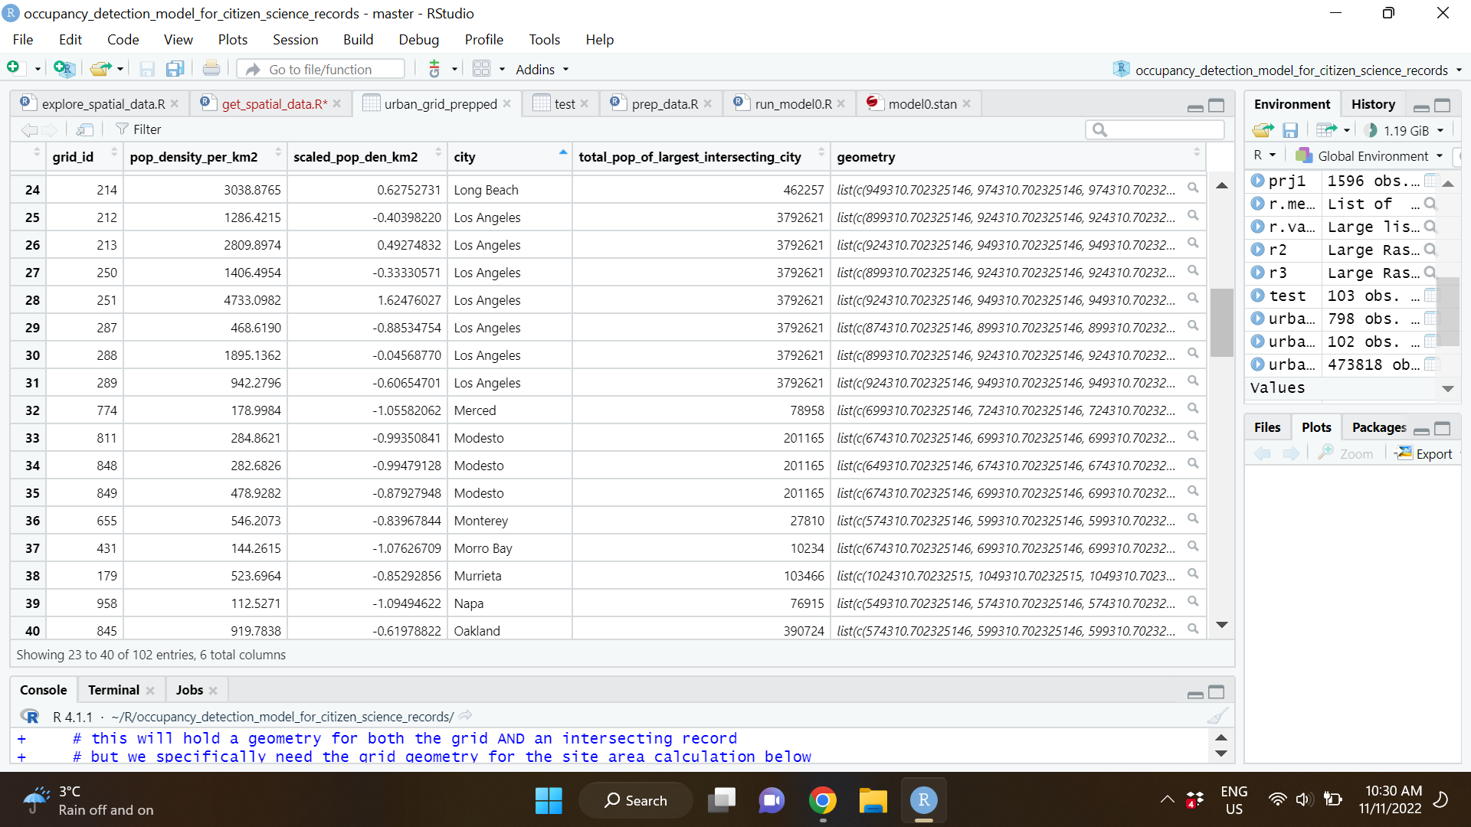

**Figure X:** **Snapshot of site covariate data.** Site (grid_id) is linked with information on population density, and also the name of the largest city with which the site intersects. This could potentially be revisited to examine effects of an additional covariate that is explicitly tied to the city name, i.e., a city wide cosmetic pesticide ban. NDVI from the raster data to be linked and added here as well.

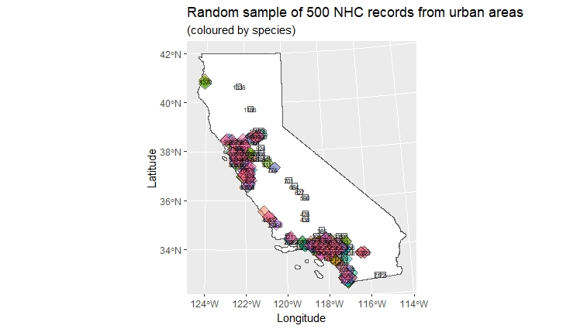

**Figure X: Random sample of NHC records from urban areas.** The data are filtered to only those NHC records that occur in urban areas. Each record is then joined to a local ecological and detection environment by joining the NHC record with the grid cell that it intersects with.

**2b) Statistical Analysis:**

The effect of differences between differences between cities on pollinators is approached using an integrated hierarchical modeling framework for natural history collections (NHCs). NHC data were not collected to address questions about population trends at large scales, and therefore several modeling considerations must be included to account for the opportunistic, presence only nature of these data (Shirey et al. 2022, Jackson et al. 2022). An integrated model form allows greater flexibility when including NHC data from different sources, which may emerge from very different underlying collection processes (Davis et al. 2022). By including all information available, an integrated model framework can estimate population parameters more precisely than if estimated from each observation process alone (Zipkin et al. 2021, Davis et al. 2022). “Integrated modelling also provides a robust framework by which to capitalize on the individual strengths of different data types while minimizing their weaknesses. For example, presence- only data are easier to collect across broad spatial and temporal extents than standardized data but information- poor relative to structured counts. Integrating presence- only and structured survey data can expand the spatiotemporal scope of inference while allowing for the robust estimation of parameters that cannot be estimated using presence- only data (Dorazio, 2014; Farr et al., 2020).” Quote from Davis et al. 2022.

**I am currently developing the model by slowly increasing the complexity, and will update here as revisions and improvements are made.**

*model_intergated.stan:* Models the effects of between city differences on pollinator occupancy to differences between cities. Here, we assume that if at least one species was collected from the site* interval*visit, then a community survey has occurred during the site* interval*visit. Here we also assume that all species may occur at any site included in the study. An updated final version of the model should especially be updated to only model pollinator occupancy within the range of the pollinator species. I.e., we should not expect to see a species restricted to southern California in northern California, and if we do not restrict the analysis for this species to southern California, then we may underestimate detection probability.

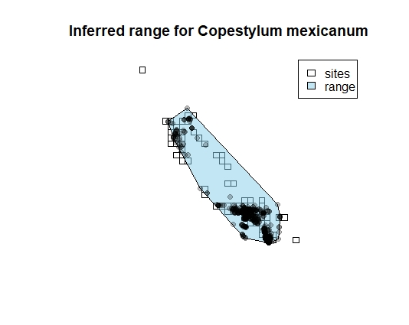 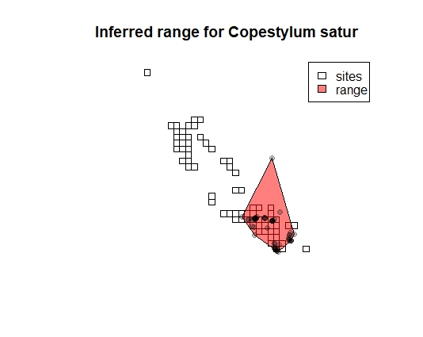

**Figure X:** Analysis is constrained to sites within the range of each species. Species ranges were inferred by drawing a convex hull around all occurrence records from 1970-present. This method likely underestimates the range of some species and overestimates the range of others but on average provides a fairly realistic representation of sites where a species could in theory exist given its physiological requirements, interaction partners, general nesting substrate requirements, and long-distance dispersal limitation.

**High level model structure**

The detection data is the product of an ecological process, and an observation process that is conditional on the outcome of the ecological process. Here, two different natural history collection (NHC) datasets with their own unique observational processes give us information about the shared latent state variable on which they are both conditional. We integrate information from both NHC sources to provide better estimates of the ecological process while allowing the data to emerge uniquely from these different sources.

Ecological process:

$$Z_{i,j,k}\sim Bernoulli(Ψ_{i,j,k})$$

Integrated observation process:

1. $V_{i,j,k}^{citizen science} |Ψ_{i,j,k},p_{i,j,k}^{citizen science} \sim Binomial\left(n, p_{i,j,k}^{citizen science}×Z_{i,j,k}\right)$; and

$V_{i,j,k}^{museum records} | Z_{i,j,k},p_{i,j,k}^{museum records} \sim Binomial\left(n, p_{i,j,k}^{museum records}×Z_{i,j,k}\right)$

*Where:*

$i$ refers to a species.

$j$ refers to a site.

$k$ refers to an occupancy interval (set of years where occupancy state is assumed to be held constant).

$l$ refers to a visit (a sampling year within an occupancy interval. To estimate values of $p$, the total number of visits within each occupancy interval must be >= 2).

$Z$ is the latent occupancy state.

$Ψ$ is the probability that a site is occupied.

$V^{citizen science}$ is the number of successful detections by citizen science across all sampling rounds (*l*) within an interval (*k*)at a site (*j*)for a species (*i*).

$V^{museum records}$ is the number of successful detections by sampling deposited in museum records.

$n$ is the maximum number of times that a successful detection may occur within an interval. $n$ may be less than the number of observation sampling rounds within an interval if museum record metadata indicates that no community surveys were conducted during a round. Community sampling is inferred to have occurred for all sites in all time periods for the citizen science data set. $n$ is contracted to 0 for all time intervals if the site is not within the species range. $n$ is assumed to be equivalent to the total number of sampling rounds within an interval if the site is in the range and community sampling has occurred.

$p^{citizen science}$ is the probability of detection within a sampling visit via the citizen science sampling process.

$p^{museum records}$ is the probability of detection within a sampling visit via the museum record sampling process.

**Low level model structure:**

*Ecological process*

$${log⁡(Ψ}_{i,j,k})=\left({Ψ0+ Ψ}_{species}\left[i\right]+{{{Ψ_{site}\left[j\right]+Ψ}_{pop density}\left[j\right]+(Ψ}_{pop density}\left[i\right] ×pop density\left[j\right])+\left(Ψ_{site area}×site area\left[j\right]\right)+{(Ψ}_{NDVI}\left[i\right] ×NDVI\left[j\right])+ Ψ}_{interval}\left[i\right]*interval\left[k\right]\right)$$

$$+spatial autocorrelation? + city factor like..$$

*Where:*

$Ψ0$ is a global, grand-mean occupancy intercept.

$Ψ_{species}$ $\sim Normal(0, σ_{Ψ_{species}})$, and represents a species-specific intercept.

$Ψ_{pop density} \sim Normal(μ_{Ψ_{pop density}}, σ_{Ψ_{pop density}})$, where $μ_{Ψ_{pop density}}$ is the mean effect of population density across species and $σ_{Ψ_{pop density}}$ describes the variation across species.

$pop density\left[j\right]$ is the (scaled) average human population density within the urban site *j*. (see data details for how this information was collected and how it was transposed onto the site given the site grid parameters specified in the run_model.R program).

is a fixed effect of spatial extent of the site. Some sites are not completely overlapping with a) land and b) the administrative area from which NHC data were drawn. A neutral process would suggest lower likelihood of occurrence in smaller sites.

$site area\left[j\right]$ is the (scaled) spatial area of the site *j* in m². (see data details for how this information was collected and how it was transposed onto the site given the site grid parameters specified in the run_model.R program).

$Ψ_{NDVI} \sim Normal(μ_{Ψ_{NDVI}}, σ_{Ψ_{NDVI}})$, where $μ_{Ψ_{pop density}}$ is the mean effect of population density across species and $σ_{Ψ_{pop density}}$ describes the variation across species.

$Ψ_{interval} \sim Normal(μ_{Ψ_{interval}}, σ_{Ψ_{interval}})$, where $μ_{Ψ_{interval}}$ is the mean effect of population density across species and $σ_{Ψ_{interval}}$ describes the variation across species; and

$interval\left[k\right]$ is the temporal interval during which an observation was/was not made.

*Observation process (citizen science data)*

$$\operatorname{logit}\left(p_{i,j,k}^{citizen science}\right)=p^{citizen science}0+p_{species}^{citizen science}\left[i\right]+ p_{site}^{citizen science}\left[j\right]+ {p_{pop density}^{citizen science}×pop density\left[j\right]+ p}_{interval}^{citizen science}×interval\left[k\right]$$

*Where:*

$p^{citizen science}0$ is a global, grand-mean occupancy intercept.

$p_{species}^{citizen science}\left[i\right]$ $\sim Normal(0, σ_{{p-citsci}_{species}})$, and represents a species-specific intercept.

$p_{site}^{citizen science}\sim Normal(0, σ_{{p-citsci}_{site}})$, and represents a site-specific intercept.

is a fixed effect of population density on detection rate (i.e., more people means potentially more iNaturalist contributors).

is the (scaled) average human population density within the urban site *j*. (see data details for how this information was collected and how it was transposed onto the site given the site grid parameters specified in the run_model.R program).

is a fixed effect of time on detection rate; and

$interval\left[k\right]$ is the temporal interval during which an observation was/was not made.

*Observation process (museum record data)*

$$logit(p_{i,j,k}^{museum})=(p^{museum}0+p_{species}^{museum}\left[i\right]+ p_{site}^{museum}\left[j\right]+ {p_{pop density}^{museum}×pop density\left[j\right]+ p}_{interval}^{museum}×interval\left[k\right]$$

$p^{museum }0$ is a global, grand-mean occupancy intercept.

$p_{species}^{museum }\left[i\right]$ $\sim Normal(0, σ_{{p-museum }_{species}})$, and represents a species-specific intercept.

$p_{site}^{museum }\sim Normal(0, σ_{{p-museum }_{site}})$, and represents a site-specific intercept.

is a fixed effect of population density on detection rate (i.e., more people means potentially more iNaturalist contributors).

is the (scaled) average human population density within the urban site *j*. (see data details for how this information was collected and how it was transposed onto the site given the site grid parameters specified in the run_model.R program).

is a fixed effect of time on detection rate; and

$interval\left[k\right]$ is the temporal interval during which an observation was/was not made.

**Software:**

Analyses were conducted using STAN version 2.21.0 (ref), implemented through the R interfacing package “rstan” using R version (). Data and code are available at: https://github.com/jensculrich/occupancy_model_for_urban_NHC_records

**Prior Predictive Checks:**

The prior distributions were chosen to be wide and weakly informative, intended to provide biologically reasonable starting values: (cauchy(0, 2.5) for all parameter means and half-cauchy(0, 2.5) for all variance parameters, which is a general standard for weak priors for logistic regression (). The priors will be widened by a factor of 3 and the results rexamined to confirm that the priors have not strongly influenced the results.

**Simulation Checks:**

Prior to application on real data, the model is fit to data that is simulated from known parameter distributions to confirm that the model has a reasonable ability to capture true parameter values within the output estimates.

**Model diagnostics:**

The model outputs are assessed to confirm that there is sufficient mixing of the chains with no/low divergent transitions. The model is set to run for n=1,000 iterations with ½ n discarded as burnin, and an adapt delta value of 0.8. These values can all be upped for the real model run, but just leaving short for now while I work out the kinks.

**Posterior Predictive Checks:**

A posterior predictive check will be conducted to validate the goodness of fit of the model. The Post-PC will be added as a generated quantity automatically output by the model, and will generally follow the form presented here: https://mc-stan.org/users/documentation/case-studies/dorazio-royle-occupancy.html.

**Sensitivity Analyses:**

* Sensitivity analysis should be conducted for the spatial grain. The default value is set at 25km X 25km. I will explore if and how the results change at 10km X 10km and 50km X 50km. Ideally, the large amount of iNaturalist data will help us narrow to a smaller spatial grain so that we can more closely tie individual pollinator occurrences with landscape features in a closer radius/more pertinent biological scale. The drawback of going to a finer scale is that a) we have less data per site informing our detection rates and b) peculiarities in individual collector behaviours may cause more observation heterogeneity between sites that are ecologically equivalent.
* Sensitivity analysis should be conducted for the occupancy interval grain. The default value is set at 3 years. I will examine how shorter (2 years) or longer (up to say 5-7 years) division of intervals impacts the results.
* Sensitivity analysis should be conducted on the era start/end dates. We will make use of data up to 2022. The data were pulled from the year 2000 and later. iNaturalist data does not begin until the year 2008. Any analyses starting before 2008 should split the observation process.
* Sensitivity analysis should be conducted on the minimum population density for a site to be included and the minimum number of records per species for the species to be included.

1. **Preliminary Results**
2. **Ideas for expansion/different approaches:**

* Model separately, bumble bees and hover flies. Do the two taxonomic groups respond the same? Can we include a species trait and ask how this mediates the ecological process? Do we expect the two groups to respond similarly or differently and why?
* Another output could be a table including the mean and 95% interval for occupancy rates and affects for all taxa. Which species are most common/most rare? Which species respond most positively/negatively to management? Which species are changing most positively/negatively with respect to time?
* Increase the scale beyond California, say all west coast states (include NV, OR, WA), southwestern states (include NV, AZ, NM, UT, CO), western states (all of the above and broader).
* Reframe the question to focus on relative abundance, with citizen science data representing encounters mediated via a thinning process while museum records still being a binary presence/absence outcome BUT where presence is higher where abundance is higher. See figure below for monarch butterflies case study (Davis et al. 2022):
* 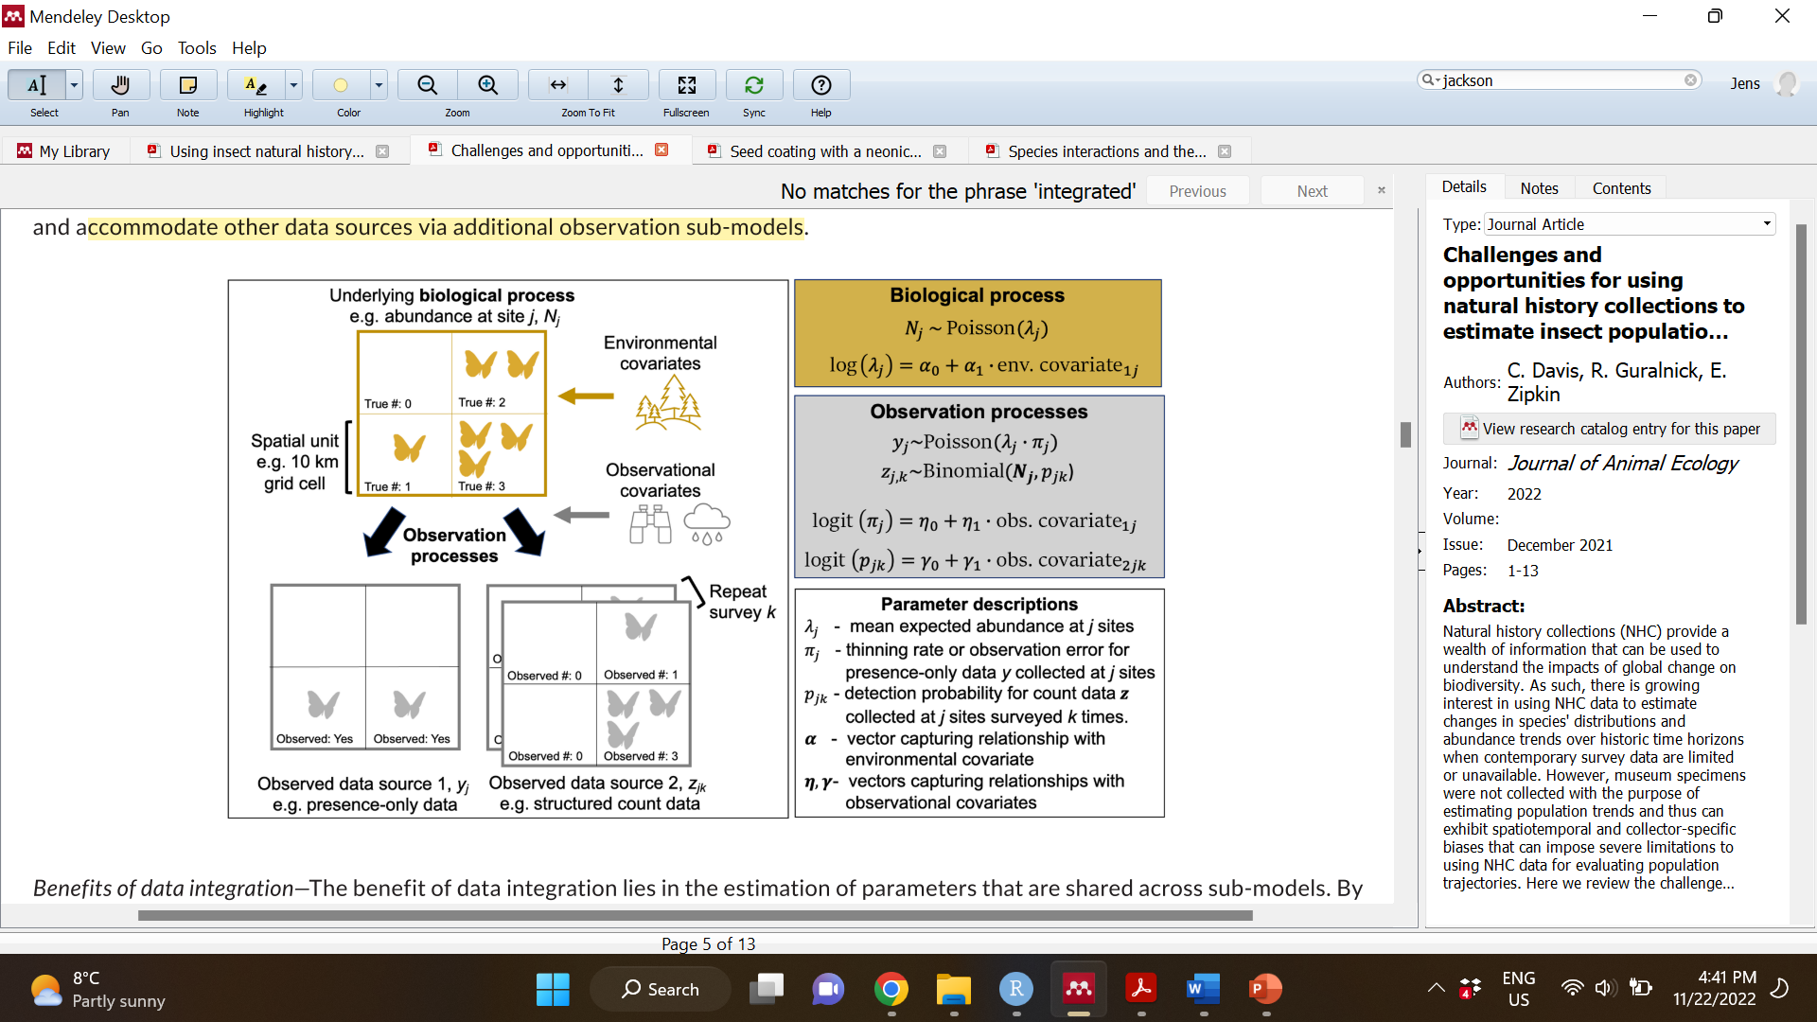

*Using natural history records to determine the effects of city-wide management differences on long-term, landscape-scale pollinator population dynamics.*

Jens Ulrich, started Nov 22, 2022.

**Contents:**

1. **Background / motivation**
   1. **Context**
   2. **Goals**
   3. **Hypotheses and predictions**
2. **Methods**
   1. **Data collection**
      1. *Data Preparation Overview*
      2. *NHC records*
      3. *Spatial data*
   2. **Statistical Analysis**
      1. Higher-level model structure
      2. Lower-level model structure
      3. Software
      4. Prior predictive checks
      5. Simulation
      6. Model diagnostics
      7. Posterior predictive checks
      8. Sensitivity analyses
3. **Preliminary Results** haven’t included anything here yet in this doc
4. **Ideas for expansion/different approaches**
5. **Background / motivation**

**1a) Context**

Currently, _ % of the global population lives in urban areas (), and urban land use will continue to increase in the coming decades, replacing natural habitat at broad landscape scales (Guneralp & Seto, 2013; U.N., 2018). As this global land use change process continues, it is critical that conservation actions and land development plans that maximize the value of urban areas for biodiversity are implemented, thereby minimizing population decline and species loss as natural habitats are replaced.

Pollinators provide a model system for examining how to manage urban landscapes for biodiversity. Studies of pollinator populations and communities along urbanization gradients show conflicting evidence for the effects of urbanization as a whole, indicating that not all cities and towns are the same for all pollinator taxa – some urban landscapes are pollinator hotspots whereas others act as agents of declines, and some pollinator species generally respond well to urban land use change whereas others fare poorly (Wenzel et al., 2020; Fenoglio et al., 2021). Quantitative comparisons of pollinator populations and communities among urban habitats may be able to shed light on what makes a city good for biodiversity and, further, what types of species may require particular

Many small-scale studies look within a city to examine how local pollinator abundance and diversity are affected by differences in the local environmental conditions such as temperature (Adams et al., 2020) or flower resources (Adams et al., 2020; Gerner and Sargent 2021), and by the landscape context including the amount of impervious surface cover and tree cover within the foraging area of local pollinator collection (Adams et al., 2020; Gerner and Sargent 2021, Hyjazie and Sargent 2022). From these studies we know that local pollinator abundance and diversity is especially tied to the local flower abundance and species richness and local proportion of native flowering plants (Adams et al., 2020; Gerner and Sargent 2021). Differences in the local pollinator abundance and diversity can also be explained by the local habitat type, which captures variation in multiple local and landscape variables (Normandin et al. 2017, Baldock et al. 2019). Meta-analysis also tells us that, across studies that collect pollinators from semi-natural areas embedded in an urban matrix, ‘patch size’ of the semi-natural area where pollinators are collected (defined as?) has the largest effect on the local abundance and diversity of those pollinators (relative to other common explanatory variables such as… ?) (Beninde et al. 2015) .

Although these types of studies clearly show that local habitat quality can influence the amount and types of pollinators locally observed, it remains unclear whether these small local habitat qualities alter the population dynamics of pollinators at larger scales. Changes to local habitat, like the addition of flower enhancements, could simply redistribute pollinators on the landscape rather than increase survival and reproduction (Kleijn et al. 2006). Alternatively, local changes to survival and reproduction due to local habitat quality could be trivial to population and community dynamics if long-term dynamics are driven by a combination of local dynamics with dispersal between populations and communities (Hanski 1998; Leibold et al., 2004), as is observed at least in spatially-explicit agricultural pollinator systems (Ponisio et al., 2019?). Comparing pollinator population and community dynamics at large scales, i.e., between replicated urban landscapes, could provide insight into whether hypothesized urban habitat drivers significantly effect pollinators at large spatial and temporal scales.

We currently lack studies that make among-city comparisons, likely because of the logistical difficulties associated with collecting standardized data in a replicated format required to perform large-scale cross landscape comparisons. The proliferation of citizen science data and digitized museum records, present an opportunity to make inferences across large spatial and temporal scales. Occupancy modeling approaches that account for spatial and temporal variation in detection ability provide a framework for inferring population trends (Mackenzie). Occupancy of a species provides a proxy for population dynamics (Mackenzie), and whether implicitly (or explicity stated) at a broader spatial scale might provide a proxy for metapopulation dynamics (whether the metapopulation as a whole is stable or declining, and what environmental factors contribute to this). Paired with modeling choices that account for the unstructured and opportunistic nature of these data, this approach has emerging potential for uncovering broad global change impacts (Altwegg et al., 2019; Kharouba et al., 2019; Guzman et al., 2021; Jackson et al., 2022; Shirey et al., 2022; Davis et al, 2022)

**1b) Goals**

Goal: To identify how land use in cities impacts long-term dynamics of pollinator populations across urban landscapes. Using a set of data extracted from (briefly describe), I will examine the effect of differences in land use among urban areas on pollinator (occupancy? Diversity?) using an occupancy modeling approach (list a source REF). I focus on data available for pollinators and land use within urban areas in the state of California, which allows me to reduce unaccounted landscape heterogeneity, and control for differences in environmental/land use data. I also focus on comparisons among urban landscapes within a contemporary era (i.e., at least after year 2000), given availability of NHC data and quality environmental data, and also to avoid the assumption that urban landscapes were comparable in a pre-modern era. The taxonomic scope of this project will include two important pollinator taxonomic groups: hover flies (Diptera – family Syrphidae) and bumble bees (*Bombus*).

**1c) Hypotheses and predictions**

H1: Because greenspace is associated with nesting habitat (non-impervious surface for ground nesting as well as vegetative materials for aboveground nesting) and potentially with increased food supply (vegetation typically includes plants that offer pollen and nectar rewards), increased greenspace in the urban landscape positively impacts the stability of pollinator metapopulations.

Prediction: After accounting for a variety of urban characteristics (population density, area of the landscape site, and spatial autocorrelation between landscape sites) as well as heterogeneity in the detection probability of pollinators across space, time and taxa, the equilibrium **occupancy rates of pollinator species among urban landscapes will be positively associated with average NDVI** (a metric of proportion (?) green vegetation cover) in the landscape. [Note that this can be said very simply – urban areas that devote more space to plant cover – a predictor of available green space - are predicted to have higher pollinator biodiversity – it might be worth looking over the entire intro to be sure that is easily plucked out by the reader. Also, your intro suggests connectivity might also be important – can you add that to your analysis?]

* 1. **Data collection:**

Mention sensitivity analyses for data collection

* 1. **Statistical Analysis – a multispecies, integrated abundance-occupancy model:**

I use a multi-species (partially-pooling information about ecological and observation processes among species), integrated (incorporating different types of observed data that arise from a shared underlying ecological process), hierarchical (explicitly partitioning a latent ecological process and a conditional observation process) abundance-occupancy (explicitly linking abundance and occupancy) model to test whether hypothesized urban habitat features that vary among cities have significant impacts on urban pollinator populations.

***Ecological Process:***

I consider occupancy (*Z*) of a species (*i*) at a site (*j*)in a time interval (*k*)to be the outcome of a Bernoulli trial with probability of success equal to $Ω_{i,j,k}$:

$Z_{i,j,k} \sim Bernoulli\left(Ω_{i,j,k}\right)$ (1)

Correspondingly, I represent the latent abundance state (*N*) using a hurdle model, where $N_{i,j,k}$ is dependent on the Bernoulli process that drives the latent occupancy state $Z_{i,j,k}$. Specifically, $N_{i,j,k}$ is drawn from a truncated count distribution when a site is occupied ($Z_{i,j,k}$ = 1). The probability of an abundance of 0, then, can be expressed as the complement of the probability of occupancy, and the probability of any abundance greater than 0 can be expressed as the product of the probability of occupancy and the probability of a discrete abundance state generated from a truncated count distribution (as in Welsh et al., 1996; Williams et al., 2017):

$P\left(N_{i,j,k} \right| Ω_{i,j,k}, η_{i,j,k},ϕ)\left\{\begin{aligned}1-Ω_{i,j,k} \\ Ω_{i,j,k} × \frac{negative binomial(η_{i,j,k},ϕ)}{1-negative binomial CDF\left(0 \right| η_{i,j,k},ϕ)}\end{aligned} \right.$ $\begin{matrix}if N_{i,j,k}=0, and \\ if N_{i,j,k}>0,\end{matrix}$ (2)

In this case, I use a negative binomial distribution as the count distribution, defined by a mean (the linear predictor $η_{i,j,k}$, which includes ecological covariates expected to effect the abundance state) and a dispersion parameter ($ϕ$). However, a Poisson distribution could be used with the advantage of avoiding estimation of the additional parameter $ϕ$ if the mean and variance of the counts are taken to be equivalent. Note, that in contrast to a zero-inflated count model (e.g., Smith et al. 2012), under this hurdle model $P\left(N_{i,j,k}= 0 \right| Z_{i,j,k}=1)=0$; a site that is occupied must have an abundance >= 1 and only the Bernoulli distribution with probability $Ω_{i,j,k}$ can produce abundances of 0.

Here, I explicitly link abundance and occupancy in the ecological model framework. There is a fundamental (mathematical and ecological) link between these two ecological quantities that is supported with empirical evidence, i.e., that abundance and occupancy rates are positively correlated (Gaston 1996; Welsh et al., 1996; Holt et al., 2002; Smith et al., 2012), including for insects (Sileshi et al., 2009). The advantage of explicitly linking abundance and occupancy includes improved computational performance and refined estimates for abundance (Smith et al., 2012). With the datasets utilized here, which include one dataset consisting of imperfectly detected abundance counts (citizen science records) and another dataset consisting of imperfectly detected presence/absence data (museum records), an explicit link between abundance and occupancy embedded in a hierarchical model allows for integrated estimation of the shared parameters for abundance and occupancy and reciprocal estimation of detection parameters. To link abundance and occupancy, and where $γ_{0}$ is a global occupancy intercept and $γ_{1}$ is the effect of species-, site-, and time-specific expected abundance on the occupancy rate, I define $Ω_{i,j,k}$ as:

${logit(Ω}_{i,j,k})= γ_{0}+ γ_{1}×log(η_{i,j,k})$ (3)

With the addition of only two extra parameters, this definition of $Ω_{i,j,k}$, allows flexibility in occupancy rates among species, sites, and time intervals (Smith et al., 2012).

***Observation Process:***

Detection biases in museum records and citizen science observations are likely to arise due to increased collection frequency in recent years, in areas with high human presence, or due more frequent collection of species that are charismatic, easy to identify, or are the target of conservation efforts/scientific research (Jackson et al., 2022; Shirey et al., 2022). I infer separate detection processes for citizen science record and museum record observation using a hierarchical model structure, allowing for full flexibility between the observation processes (as opposed to e.g., assuming that the detection rate of a species by citizen science methods is related to its detection rate in the museum records, or that the two processes change similarly through time). With this structure the variation among outcomes of temporally replicated data collection events are then used to infer the observation process while variation for each species between across sites and across time intervals are used to infer an underlying ecological process (driving the abundance and occupancy states) (Nichols, 2004; Kery & Royle 2016).

I consider the individual-level detection of abundance by citizen science records ($V^{cit.sci}$) to be the outcome of $N$ binomial trials, where $N_{i,j,k}$, is the latent abundance state, with a probability (detection rate) $p^{cit.sci.}$, where $p^{cit.sci.}$ is a linear predictor including covariates that are expected to affect the citizen science detection process. The variation in counts across visits (*l*) is used to infer the detection probability.

$V_{i,j,k, l}^{cit. sci.} | N_{i,j,k} \sim \left\{\begin{aligned}0 \\ Binomial(N_{i,j,k},{ p}_{i,j,k}^{cit.sci.})\end{aligned}\right.$ $\begin{matrix}if N_{i,j,k}=0, and \\ if N_{i,j,k}>0,\end{matrix}$ (4)

Similarly, I consider that the species-level detection of occupancy by museum records ($V^{museum}$) to be binomially-distributed, but where $V_{i,j,k}^{museum.}$ is the number of surveys (years) in the time interval in which the species was detected at a site. Further, the likelihood of $V_{i,j,k}^{museum.}$ is here predicated on *n* trials, where $n_{j,k}$ indicates the number of years in which a community-wide survey occurred at the site during the time interval (and thus the maximum number of times that a species could be detected at that site during that time interval). The detection rate, $p^{museum}$, is a linear predictor including covariates that are expected to affect the museum detection process.

$V_{i,j,k}^{museum.} | N_{i,j,k} \sim \left\{\begin{aligned}0 \\ Binomial(n_{j,k},{ p}_{i,j,k}^{museum})\end{aligned}\right.$ $\begin{matrix}if Z_{i,j,k}=0, and \\ if Z_{i,j,k}=1,\end{matrix}$ (5)

Failing to consider whether species could have been sampled (scaling $n_{j,k}$ based on the number of community sampling events) can cause underestimates of detection rates and consequently bias estimates of abundance (Guzman et al., 2021). Community sampling events each site in each year within each time interval were inferred prior to running the analysis. Specifically, if records from 2 or more species were collected from a site in a single year from the same institution, I designated that a community sampling event had occurred. A more conservative approach might be to group records by individual collector names rather than by institution, however, by visual review of the museum record data it appears that collector names even within the same year are variable (punctuation, inclusion of first and middle names) and, further, the museum records appear to include many ‘bioblitz’ type sampling events where a team of researchers or volunteers surveyed the community at same site on the same day. Community sampling events were inferred separately for the two taxonomic groups (Syrphidae and *Bombus*).

Note that in contrast to a classic binomial N-mixture model (Kery & Royle, 2016), the underlying abundance state estimated under this framework is a relative rather than true measure. This model violates two key assumptions required to estimate true abundance. First, the size of the population must remain constant between visits. The insects considered here have an annual life cycle with death of the adult generation each winter, and so we expect at least some inter-annual abundance variation to occur, precluding the estimation of the true abundance. However, if inter-annual abundance fluctuation within a time interval (here considered to be a set of 3 years) is non-trivial and non-random with respect to our ecological covariates (I think they talk about this in the Murray et al., population ecology textbook), then this modelling approach could produce biased estimates of the drivers of urban pollinator abundance. This limitation is a key drawback to N-mixture modelling approaches that is untestable without auxiliary data (I think they talk about this in the Murray et al., population ecology textbook).

Additionally, our approach violates the assumption that all individuals are available for detection during each visit (each year). In truth, insect abundances at these large spatial scales are likely orders of magnitude larger than the maximum number of records captured by citizen scientists (i.e., millions or more individual insects existing on the landscape versus a few or dozens of records obtained per year). Here, we consider that the number of records observed of a species at a site in each year by citizen scientists arises from a constant ‘pre-thinning’ process that reduces the millions of insects on the landscape to a proportional maximum number of insects that could be observed. In practice, this means that as variation of a species at a site across years within a time period decreases (e.g., counts of 99, 100, and 101) then detection rate is likely to be high and the observed abundance close in size to this abstract pre-thinned relative abundance; and in contrast, as variation of a species at a site across years within a time period decreases (e.g., counts of 5, 25, and 75) then detection rate is likely to be low and the observed abundances much lower in size to this abstract pre-thinned relative abundance. If the proportionality between true abundance and maximum observable abundance is constant, then variation in detection that obscures the ecological process should be reliably captured by the observation process covariates that allow and account for variation in sampling efforts.

The same model, including the same linear predictors for the ecological process and for the observation processes were fit independently for the two taxonomic groups, Syrphidae and *Bombus*.

***Linear predictor for ecological process:***

$$log \left(η_{i,j,k}\right)=η0+ η_{species}\left[i\right]+η_{site}\left[j\right]+η_{impervious surface}\left[i\right]×impervious surface\left[j\right]+η_{plant cover}\left[i\right]×plant cover\left[j\right]+η_{site area}×site area[j]$$

Where:

$η0$ is a global, grand-mean occupancy intercept.

$η_{species}\sim Normal(0, σ_{η_{species}})$, and represents a species-specific intercept.

$η_{site}\sim Normal(0, σ_{η_{site}})$, and represents a site-specific intercept.

$η_{impervious surface}\sim Normal(μ_{η_{impervious surface}}, σ_{η_{impervious surface}})$; where $μ_{η_{impervious surface}}$ is the mean effect of impervious surface across species and $σ_{η_{impervious surface}}$ describes the variation across species.

$impervious surface\left[j\right]$ is the (scaled) proportion of impervious surface within the urban site *j*. (see data details for how this information was collected and how it was transposed onto the site given the site grid parameters specified in the run_model.R program).

$η_{plant cover}\sim Normal(μ_{η_{plant cover}}, σ_{η_{cover}})$, where $μ_{η_{plant cover}}$ is the mean effect of the plant cover metric across species and $σ_{η_{plant cover}}$ describes the variation across species.

$plant cover\left[j\right]$ is the (scaled) plant cover metric of the urban site *j*. (see data details for how this information was collected and how it was transposed onto the site given the site grid parameters specified in the run_model.R program).

is a fixed effect of spatial extent of the site. Some sites are not completely overlapping with a) land and b) the administrative area from which NHC data were drawn. A neutral process would suggest lower likelihood of occurrence and abundance in smaller sites (ref).

$site area\left[j\right]$ is the (scaled) spatial area of the site *j*. (see data details for how this information was collected and how it was transposed onto the site given the site grid parameters specified in the run_model.R program).

***Linear predictors for observation processes:***

The log-odds of detection of an individual occurrence from a pool of available occurrences (assumed to be proportional to the true abundance of insects on the landscape) by the citizen science detection process is defined by the linear predictor:

$$\operatorname{logit}\left(p_{i,j,k}^{citizen science}\right)=p^{citizen science}0+p_{species}^{citizen science}\left[i\right]+ p_{site}^{citizen science}\left[j\right]+ {p_{pop density}^{citizen science}×pop density\left[j\right]+ p}_{interval}^{citizen science}×interval\left[k\right]$$

*Where:*

$p^{citizen science}0$ is a global, grand-mean occupancy intercept.

$p_{species}^{citizen science}\left[i\right]\sim Normal(0, σ_{{p-citsci}_{species}})$, and represents a species-specific intercept.

$p_{site}^{citizen science}\sim Normal(0, σ_{{p-citsci}_{site}})$, and represents a site-specific intercept.

is a fixed effect of population density on detection rate (i.e., more people means potentially more iNaturalist contributors).

is the (scaled) average human population density within the urban site *j*. (see data details for how this information was collected and how it was transposed onto the site given the site grid parameters specified in the run_model.R program).

is a fixed effect of time on detection rate; and

$interval\left[k\right]$ is the temporal interval during which an observation was/was not made.

The log-odds of detection of one or more records (species-level detection versus non-detection) by the museum records sampling process is defined by the linear predictor:

$$logit(p_{i,j,k}^{museum})=(p^{museum}0+p_{species}^{museum}\left[i\right]+ p_{site}^{museum}\left[j\right]+ {p_{pop density}^{museum}×pop density\left[j\right]+ p}_{interval}^{museum}×interval\left[k\right]$$

$p^{museum }0$ is a global, grand-mean occupancy intercept.

$p_{species}^{museum }\left[i\right]$ $\sim Normal(0, σ_{{p-museum }_{species}})$, and represents a species-specific intercept.

$p_{site}^{museum }\sim Normal(0, σ_{{p-museum }_{site}})$, and represents a site-specific intercept.

is a fixed effect of population density on detection rate (i.e., more people means potentially more iNaturalist contributors).

is the (scaled) average human population density within the urban site *j*. (see data details for how this information was collected and how it was transposed onto the site given the site grid parameters specified in the run_model.R program).

is a fixed effect of time on detection rate; and

$interval\left[k\right]$ is the temporal interval during which an observation was/was not made.

***Range restriction:***

At the large spatial scale considered here, not all sites are within the distributional range of all species, i.e., some species cannot occur at some sites. Failing to restrict the analysis for each species to sites within the range of each species can bias the parameter estimates for the ecological and observation processes (Guzman et al., 2021; Shirey et al., 2022).

To restrict the analysis to sites within the range of each species, I drew a convex-hull spatial polygon around all occurrence records from the year 2000 to present (library ‘sf’ in R), and determined which sites overlap with each polygon (as in Shirey et al., 2022). Using the intersections, I constructed a binary indicator array of sites within range versus sites outside of range for each species (held constant across time intervals) that is used to forbid out-of-range species by site combinations from contributing to parameter likelihood.

***Software and Model Implementation:***

Analyses were conducted using STAN version 2.21.0 (ref), implemented through the R interfacing package “rstan” using R version ().

In brief, the posterior likelihood of the parameters given the data and the priors from each iteration of the MCMC algorithm is defined by marginalizing across different possible latent states. If a species was observed at a site (within the range) in a time interval by either NHC data set, then it is considered to both occupy the site and have an abundance greater than 0. The likelihood of the parameters across a vector of abundance from the maximum observed abundance to an abundance of K is calculated. If, however, a species was never observed at a site (within the range) in a time interval by either NHC data set, then the species could either a) not occupy the site and have an abundance of 0, or b) be present at a site with some abundance greater than 0, but was never detected. The likelihood of the parameters across a vector of abundance from 0 to K is calculated, and the log probability of the parameters is summed.

In either case the value of K is generated before fitting the model, where I defined K as:

$$K={(max{observed citizen science count}}_{i,j,k}+5)×5$$

The addition of 5 allows for a possibility for an latent relative abundance greater than 0 despite any detections, and the multiplication by 5 all sets the cap on the latent relative abundance search as 5 times greater than the max observed count plus 5. K should be carefully chosen and evaluated, given that values of K that are lower than the latent relative abundance will truncate the estimates for the linear predictor $log \left(η_{i,j,k}\right)$ as it will hold the parameter search back from estimating a larger latent abundance with lower detection rates, while values of K far greater than the latent abundance can significantly decrease computational efficiency and model run times (Kery & Schaub, 2012).

Data and code with instructions for fitting the model are available at: https://github.com/jensculrich/occupancy_model_for_urban_NHC_records

**Prior Distributions:**

Most priors were chosen to be weakly informative. Normal(0, 2) priors were used for parameter means for the abundance linear predictor, intended to hold the posterior distributions of the parameters close to 0 (no effect of parameters on detection or abundance-occupancy) unless the data provide convincing evidence to the contrary. Normal(0, 2) priors were used for parameter means for the detection log-odds linear predictor, intended to hold the posterior distributions of the parameters close to 0 (parameters do not shift detection rates for individuals or species, respectively, above or below 50/50 random chance) unless the data provide convincing evidence to the contrary.

Weakly-informative half-Normal(0, 1) priors were used for all variance parameters, which encourages stronger pooling within clusters (e.g., species abundance responds fairly similarly to a covariate of impervious surface cover), unless the data provide convincing evidence to the contrary.

A strongly-informative prior is used for $γ_{1}$ (effect of abundance on occupancy). Specifically, I use a half-normal prior (lower bound at 0) with a mean of 0 and standard deviation of 1. The lower bound on the prior is based on the theoretical and empirically supported relationship between abundance and occupancy (ref), forcing the abundance-occupancy relationship to be positive. This strong prior choice was implemented to assist with model fit and identifiability of the model given the large number of parameters to be estimated from the data.

The priors (could be) widened by a factor of say 2 or 3 and the results rexamined to examine whether the priors have strongly influenced the results.

**Simulation Checks:**

Prior to application on real data, the model was fit to a dataset with a similar sample size and that was simulated from known parameter distributions. This allowed us to confirm that the model accurately estimates true parameter values, given that the assumptions of the model are met.

**Model Diagnostics:**

The model outputs were assessed to confirm that there is sufficient mixing of the MCMC chains (all Rhat values < 1.1) with no/low divergent transitions, and an effective sample size of >100 for all parameters. The model is set to run for n=1,000 iterations with ½ n discarded as burnin, with an adapt delta value of 0.8. These values can all be upped for the real model run, but just leaving short for now while I work out the model application.

**Posterior Predictive Checks:**

A chi-squared discrepancy test (Kery & Schaub, 2012) was used to evaluate the goodness-of-fit of the model. The discrepancy test compares the squared distances between observed counts and detection/non-detection created by a random number generation and the parameters in each step of the MCMC algorithm versus the expected values for the counts given the parameters in each step of the MCMC algorithm to the squared distances between real NHC citizen science counts and museum record detections/non-detections versus the expected values for the counts given the parameters in each step of the MCMC algorithm.